Creativity and innovation (diffusion)
- Creativity is the generation of novel and useful ideas
- Innovation is the whole process from idea generation (creativity) to implementation
  - Innovation requires favourable evaluation of colleagues and selection of your idea by your company. A social process
- Innovation diffusion is the success adoption and implementation of products and services innovated by others.

Case study – cell phone industry
- Creativity refers to the generation of novel ideas: Bell Labs idea was novel because it was different from existing theories on remote communication e.g., no satellite was needed.
  - The idea was also useful because it was the basis of new technology improving our everyday lives.

Antecedents of creativity

Component model of creativity
Component model of creativity (Amabile, 1983) cites expertise, intrinsic motivation and creative skills as the antecedents of creativity
- Intrinsic motivation – degree to which you enjoy your work
- Expertise – memory, factual knowledge, technical proficiency in the work domain
  - Bell Lab recruited PhD students with expertise. They chased diversity
- Creative skills – personal tendency to pursue creativity, e.g., through risk-taking
- Model criticised as tautological as you need creative skills to be creative

Dual pathway model
Dual pathway to creativity model (Nijstad, 2010) proposes two main drivers of creativity:
- Cognitive flexibility: use of broad cognitive categories through flexible switching among categories to generate ideas based on remote associations
  - iPhone combines seemingly distil functions
- Cognitive persistence: systemic exploration of only a few cognitive categories
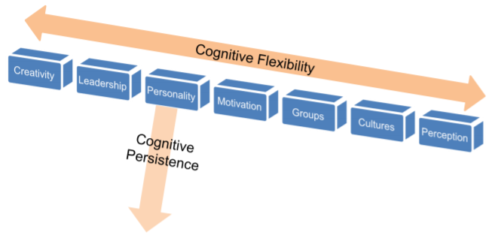

- Enhancing creativity can therefore involve splitting question into the cognitive categories, writing down some ideas within these categories, then randomly combine theories and ideas from different cognitive categories.
  - Is there a link between leadership type and cultural tightness / looseness?
- Value of the theory is the first step toward understanding creativity as a process, identifying that there are factors which affect it

Templates of creativity
Templates of creativity: Goldenberg developed a “creativity template” based on cognitive flexibility
- Idea is to split a product or service into its essential components or categories, and then further explore these categories and “play around” with them”
  - Removal template: dissemble the subject of the idea (product) and think about which components could be removed to add value or create a different offering
    - Remove the legs of a chair to create a car seat
  - Replacement template: replace one component from an existing product with a different component
    - Replace the legs of a chair with wheels = wheelchair
  - Relationship template: create a new relationship between two previously unrelated components of the product and/ or its environment.

From creativity to innovation
Are creative companies innovative – do you need to be the first proposer of creative ideas to be innovative?
The stages of innovation:
- Idea generation (creativity)
- Idea evaluation – present your creative idea to colleagues / superiors who can evaluate it
- Idea selection – if colleagues also believe your idea is creative, they will selective
- Idea implementation – collaborate with other teams in your organisation to bring your idea to the market.
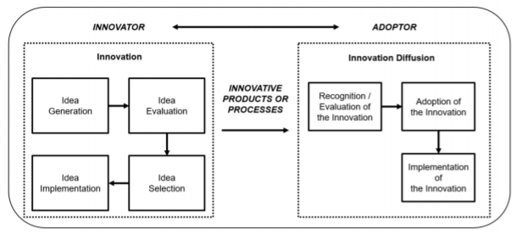

- Bell Labs had a creative idea, but rejected the idea of implementing the cell phone, arguing that customers are not ready.
  - Motorola favourably evaluated the cell phone idea and thus successfully implemented the idea, becoming the innovator.
- Innovation is a social process; creative ideas cannot innovate your company without support. Therefore, you do not need to be the initial proposer of the idea to innovate.
  - Group dynamics class explains why companies can reject creative ideas

Creativity vs innovation example
Was the iPhone creative or innovative
- Cognitive flexibility combining different functions e.g. phone, music, internet
- Applied the removal template of Goldenberg
- However, theoretically it was not creative: Samsung electric launched the same product in 2003, but it completely failed as it had too many errors.
  - Samsung were creative, but not innovative as the ideas weren’t implemented.
- Customers observe innovation, not creativity, so this is what organisations should focus on.
  - Customer-driven innovation – new product should satisfy their needs and wants

Innovation diffusion & the adopter’s dilemma
- Blackberry’s decline. Iphone release – Blackberry didn’t pay attention and thought iPhone couldn’t work, so refused to adopt it
  - Samsung recognised the value of the app store and wanted to fit in the Apple trend which is why it survived
- Risk of not adopting: losing the competition, market share can decline quickly if consumer tastes shift, lost time further accentuates the innovators first-mover advantage
- Risk of adopting: market ambiguity and implementation ambiguity – is this real innovation and can our capabilities implement it?
  - High costs and inertia of success (Blackberry successful and felt no need to change)

Creativity recap
- Creativity is the generation of novel and useful ideas. It can be boosted by applying the component theory, dual pathway theory, or creativity template theory.
  - Component theory – motivation, expertise, creative skills
  - Dual pathway – cognitive flexibility and persistence
- Innovation is often more crucial than creativity as it brings the product to the market. Creative companies are not always innovators.
- Innovation diffusion is about adopters who evaluate the innovative product, adopt it and implement it. This is subject to an adopter’s dilemma where there are risks of both adopting and not adopting the innovative product.
  - Patent issue can accentuate this issue

Implications for entrepreneurs
- Many countries do not have creative ideas but innovate using others’ creative ideas. Thus, if you have creative ideas you should seek to patent your ideas so that you can leverage them.
  - Entrepreneurs should have legal advisors – important to focus on patenting as well as idea generation

Further reading
- Component model of creativity – Grant A (2011) The necessity of others is the mother of invention: Intrinsic and prosocial motivations, perspective taking, and creativity. Academy of Management Journal, 54(1): 73-96. Thirdly, empirical evidence has shown that the relationship between intrinsic motivation and creativity is inconsistent – sometimes, this relationship is positive as this model posits; other times, this relationship becomes non-significant (for more details see, Grant & Berry, 2011)
- Goldenberg, J., Mazursky, D., & Solomon, S. 1999. The fundamental templates of quality ads. Marketing science, 18(3): 333-351.

Nijstad (2010) – dual pathway to creativity model
Creativity is a function of cognitive flexibility and cognitive persistence. Situational and dispositional variables can influence creativity through their effects on these variables.
- Situationally induced positive moods stimulate creativity (Baas et al, 2008) perhaps due to release of dopamine, which increases cognitive flexibility (Ashby et al, 1999)
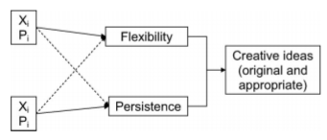
  - Flexibility – ease of switching approach and considering a different perspective
  - Persistence – degree of sustain and task-directed cognitive effort
  - Dotted lines highlight where relationships can be weak or even negative
- The flexible pathway is about achieving creative insights by flexibly switching through broad and inclusive cognitive categories, which are remotely related (Amabile). Creativity is often about making new connections among distant ideas (Koestler, 1964).
  - Cognitive flexibility associated to dopamine (Ashby, 1999) and reduced levels of latent inhibition (Carson et al, 2003), the latter allowing more distant ideas to enter working memory, leading to more original vs habitual responses.
    - However when threshold for ideas to enter working memory is lower, risk increased distractibility (Dreisbach, 2004)
    - Reduced levels of latent inhibition therefore only associated w flexibility for clever people (Carson et al, 2003).
- The persistence pathway is about systemic exploration of possibilities and an in-depth exploration of only a few perspectives (Boden, 1998, Newell and Simon, 1972). These processes initially lead to readily available solutions; persistence is required to eliminate these ideas and eventually arrive at original responses. Systemic thinking requires full focus on the task at hand (Dreisbach and Goschke, 2004).
  - Persistent people are less distractable but less flexible
- The relation between the pathways appears negatively related due to the trade-off between the two (Cools, 2008). However can use a combination e.g. flexibility path to discover new approaches then systemic approach to explore these approaches. Thus possible to use both approaches.

Amabile (1996) – componential model of creativity
Qualities which promote creativity:
- Various personality traits (41%): persistence, curiosity, energy
- Self-motivation (40%): excited by the work, feeling of working on something important
- Risk-orientation (34%): attracted to challenge, orientated towards taking risks
- Expertise in the area (33%): expertise and acquired knowledge in the particular field
- Qualities of the group (30%): synergy arising from group qualities
- Diversity of experience (18%)
- Social skill (17%)
- Intelligence (13%)
- Naivety (13%): not being bound by preconceptions of old norms
Componential model of creativity: three major components necessary for individual creativity in a specific domain: domain-relevant skills, creativity-relevant skills, and intrinsic motivation
- Domain relevant skills include factual knowledge, technical skills. These dictate response possibilities from which the response to a problem is synthesised and the knowledge against which the response is judged. In other words, cognitive pathways for solving a problem, the ‘network of possible wanderings’ (Newell and Simon, 1972)
  - Amabile (1987): expertise, brilliance and special cognitive abilities (+) & unskilled (-)
  - Thought of as the raw materials for creativity productivity. Necessary, but not sufficient, to know about the problem area in order to tackle it creativity. Specific domains may require technical skills too, increasing the importance of this component
- Creativity-relevant skills. Incentive and domain-relevant skills will lead to an acceptable performance, but not necessarily creative without these skills. These sum to create a cognitive style favourable to taking new perspectives and applying heuristics to explore new cognitive pathways
  - Risk orientation, group qualities, diverse experiences, social skills, naivety, absence of dependence on social approval (Feldman, 1980), perseverance
  - Cognitive-perceptual set: breaking perceptual and cognitive sets, keeping response options open for as long as possible by delaying judgement, remembering accurately
  - Knowledge of heuristics which generate novel ideas: when all else fails, try something counterintuitive (Newell, 1962), make the familiar strange (Gordon, 1961)
- Intrinsic task motivation. Being unmotivated and being externally motivated are detrimental to creativity (1st and 4th most important). Domain-skill and creative thinking can’t compensate for a lack of motivation, but to some extent motivation can compensate for a deficiency in these areas. Task motivation is the difference between what one can do and what one will do.
  - Subtle changes in work environment can increase individual creativity via motivation
  - Two elements of motivation in this model: person’s liking of a particular task and the person’s perceptions of why they are undertaking the task.

Kim and Zhong (2017) ideas rise from chaos
- Hierarchical information structure reduces complexity of info processing and increases efficiency. However, it might reduce creativity (novel and useful combination of existing info) by obstructing the ability to combine info from distal conceptual categories. This reduces cognitive flexibility, thus creativity (De Dreu et al, 2008). How?
  - Contextual-priming, whereby the higher-order category primes how we interpret the info in that category, reducing the possibility for alternative uses of the info. Asch (1946) shows conceptual overlap between focal and contiguous info changes the interpretation of the focal info.
    - Contextual priming = individuals sorting info into most accessible category (Anderson, 1996). This reduces cognitive persistence thus creativity.
  - Second, hierarchical structure organises units of info in ways which result in uneven probability of information units being next to each, therefore reducing probability of making distal connections between concepts
- Having a lot of info increases creativity by giving a higher probability of generating new combos (Simonton, 1999). However relationship is ambiguous, suggest suggesting that how info is stored and presented is also a critical factor affecting creativity.

